**Binary Search Concept –**

Binary Search -

1 - Binary Search for sorted array - increasing & decreasing

2 - sum of 2 elements of array equal to target elemnt thern print yes, using Binary Search concept -

**Qun – Write down a program for Binary Search and its implementation for Sorted Array.**

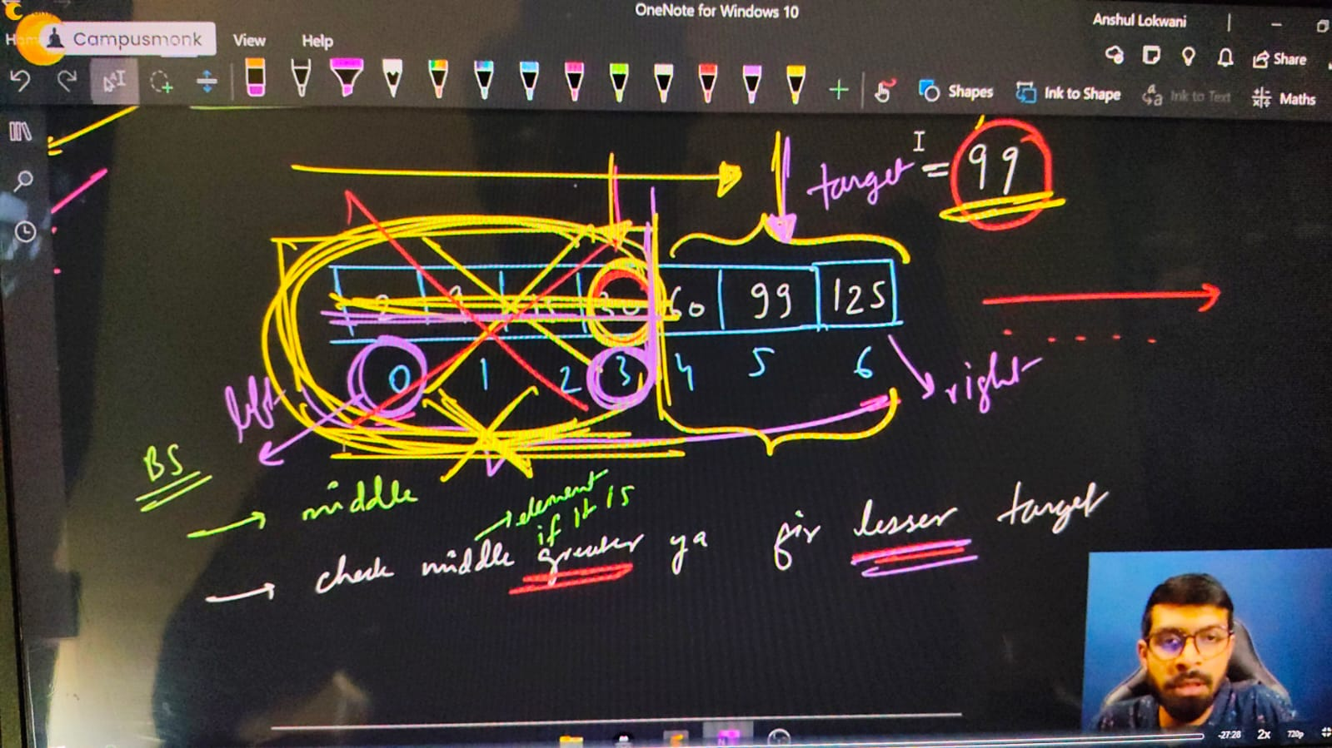

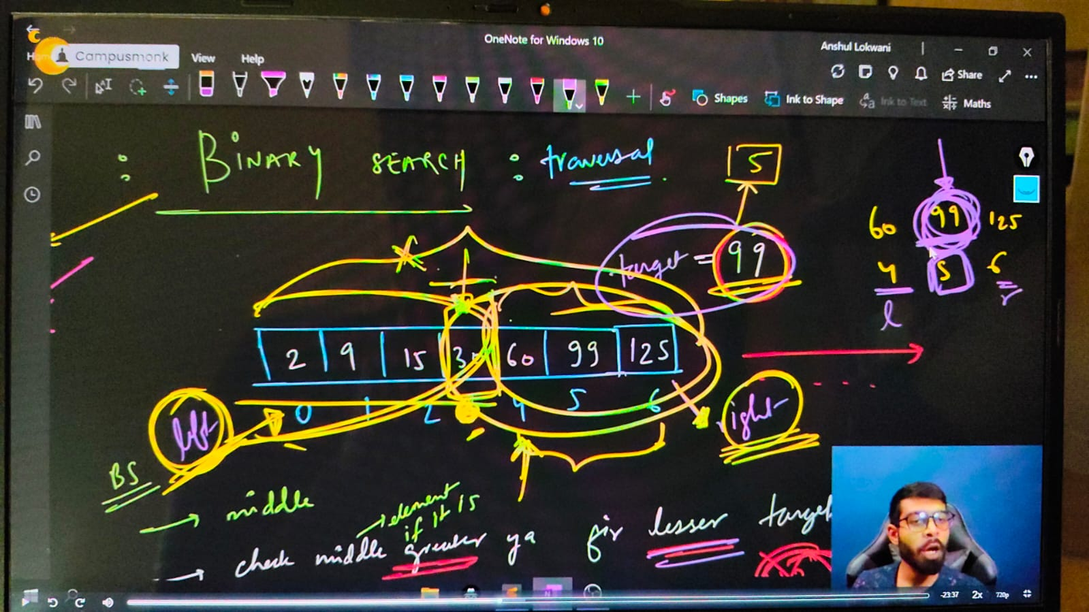

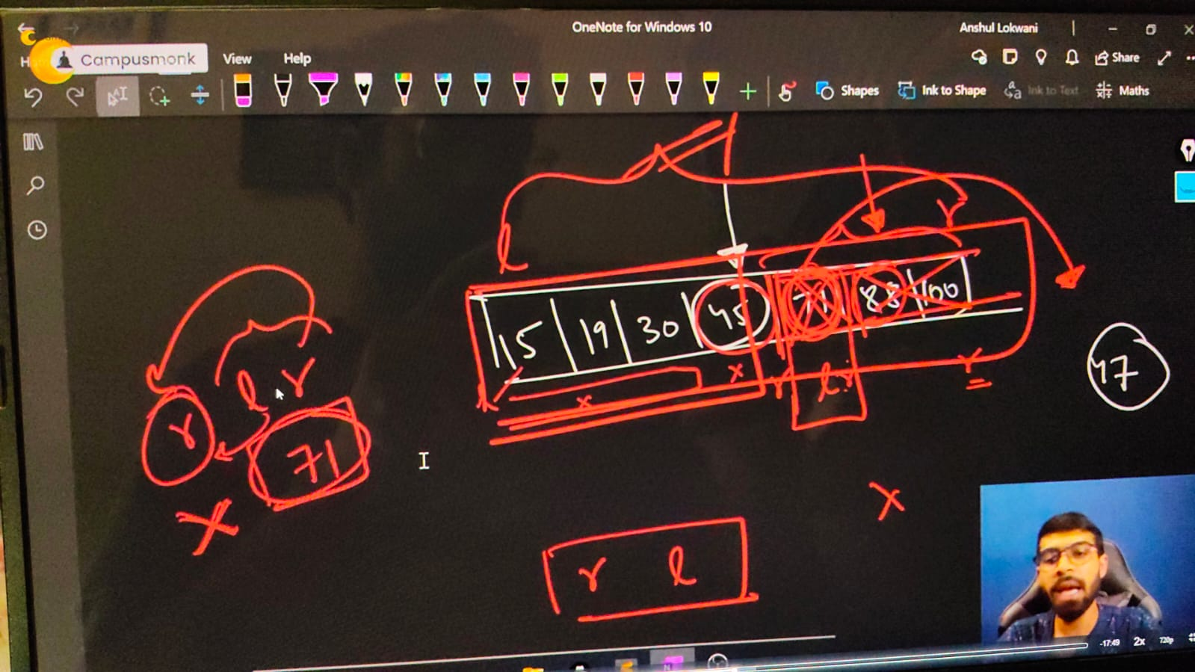

#include <bits/stdc++.h>

// #include <iostream>

// #include<algorithm>

// #include<climits>

// #include<string>

// #include<cctype>

using namespace std;

int main()

{

**// Binary Search Concept - Conditionn - Must be for Sorted Arraay only.  All elem,ents /w Lfet and ight is known as Search Space**

    // int n;

    // cout << "Enter the size of array - ";

    // cin >> n;

    // int arr[n];

    // cout << "MEntion the array values you want tot inserett - " << endl;

    // for (int i = 0; i < n; i++)

    // {

    //     cin >> arr[i];

    // }

    // cout << endl;

    // cout << "So, your enteres aray is - " << endl;

    // for (int i = 0; i < n; i++)

    // {

    //     cout << arr[i] << " ";

    // }

    // cout << endl;

    // int targetelement;

    // cout << "Now, let me knw what is your Targeted Element" << endl;

    // cin >> targetelement;

    // // Bianry Search process -

    // int left = 0, right = n - 1;

    // while (left <= right)

    // {

    //     int mid = (left + right) / 2;

    //     if (arr[mid] == targetelement)

    //     {

    //         cout << "Element is here and found at - " << " " << mid << endl;

    //         return 0;

    //     }

    //     else if (arr[mid]>targetelement)

    //     {

    //         right = mid-1;

    //     }

    //     else

    //     {

    //         left = mid+1;

    //     }

    // }

    // cout<<"Element not found braddy"<<endl;

    /*

    Enter the size of array - 7

    MEntion the array values you want tot inserett -

    1 2 3 4 5 6 7

    So, your enteres aray is -

    1 2 3 4 5 6 7

    Now, let me knw what is your Targeted Element

    5

    Element is here and found at -  4

    Enter the size of array - 7

    MEntion the array values you want tot inserett -

    1 2 3 4 5 6 7

    So, your enteres aray is -

    1 2 3 4 5 6 7

    Now, let me knw what is your Targeted Element

    8

    Element not found braddy

    Enter the size of array - 10

    MEntion the array values you want tot inserett -

    89 78 45 56 12 23 32 21 65 99

    So, your enteres aray is -

    89 78 45 56 12 23 32 21 65 99

    Now, let me knw what is your Targeted Element

    12

    Element is here and found at -  4

    */

    // T.C - of BS  is given by (log n). For n operations juts half - because either in Ight or in Left

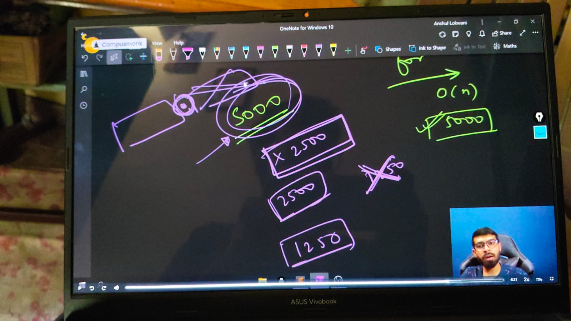

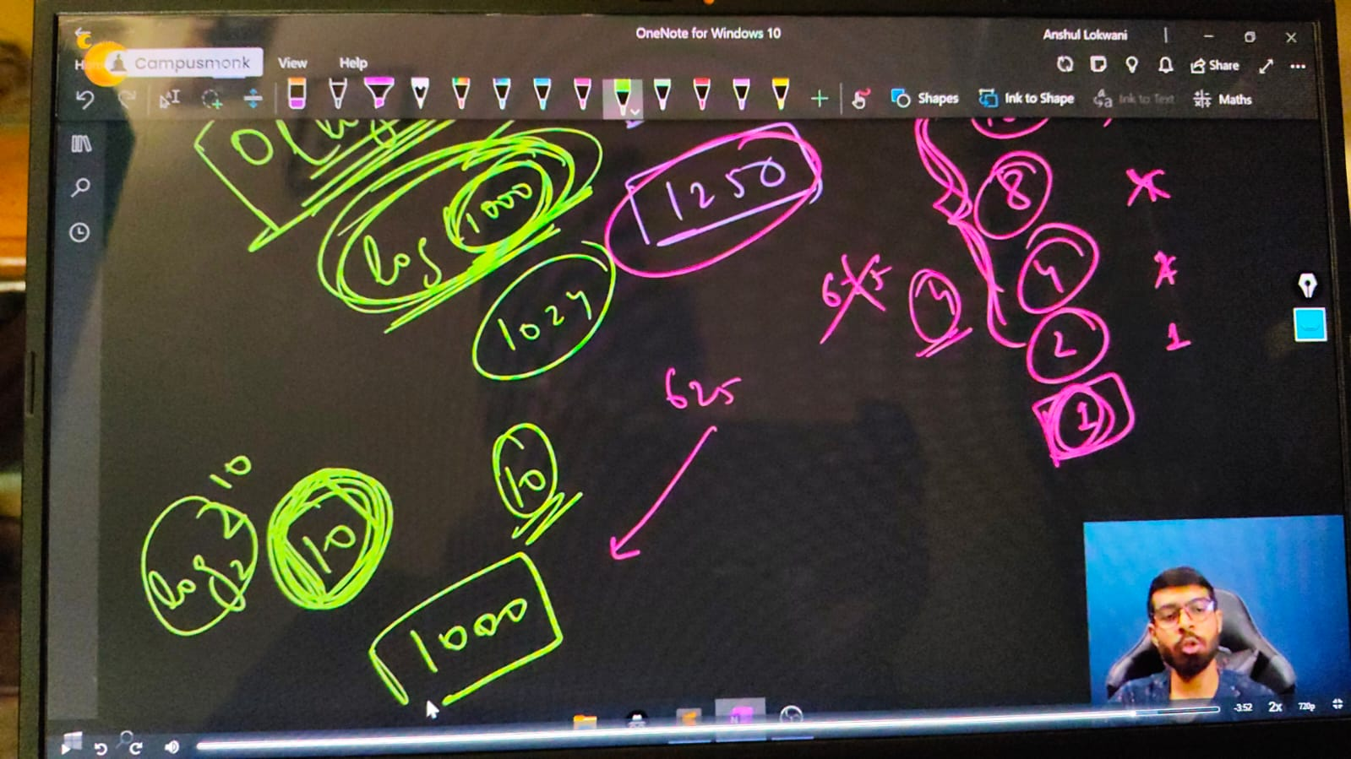

// ____________ ____________

**// Binary Search for the decreasing oder of array elements -**

    //   int n;

    // cout << "Enter the size of array - ";

    // cin >> n;

    // int arr[n];

    // cout << "MEntion the array values you want tot inserett - " << endl;

    // for (int i = 0; i < n; i++)

    // {

    //     cin >> arr[i];

    // }

    // cout << endl;

    // cout << "So, your enteres aray is - " << endl;

    // for (int i = 0; i < n; i++)

    // {

    //     cout << arr[i] << " ";

    // }

    // cout << endl;

    // int targetelement;

    // cout << "Now, let me knw what is your Targeted Element" << endl;

    // cin >> targetelement;

    // // Bianry Search process -

    // int left = 0, right = n - 1;

    // while (left <= right)

    // {

    //     int mid = (left + right) / 2;

    //     if (arr[mid] == targetelement)

    //     {

    //         cout << "Element is here and found at - " << " " << mid << endl;

    //         return 0;

    //     }

    //     else if (arr[mid]>targetelement)

    //     {

    //         left = mid+1;

    //     }

    //     else

    //     {

    //         right = mid-1;

    //     }

    // }

    // cout<<"Element not found braddy"<<endl;

    /*

    Enter the size of array - 7

    MEntion the array values you want tot inserett -

    7 6 5 4 3 2 1

    So, your enteres aray is -

    7 6 5 4 3 2 1

    Now, let me knw what is your Targeted Element

    3

    Element is here and found at -  4

    Enter the size of array - 7

    MEntion the array values you want tot inserett -

    7 6 5 4 3 2 1

    So, your enteres aray is -

    7 6 5 4 3 2 1

    Now, let me knw what is your Targeted Element

    6

    Element is here and found at -  1

    Enter the size of array - 7

    MEntion the array values you want tot inserett -

    7 6 5 4 3 2 1

    So, your enteres aray is -

    7 6 5 4 3 2 1

    Now, let me knw what is your Targeted Element

    56

    Element not found braddy

    */

    // ____________ ____________ ____________ ____________ ____________

**//Array Qun 7 using Binary Search- If sum of 2 elements of array equal to target elemnt thern print yes, using Binary Search concept –**

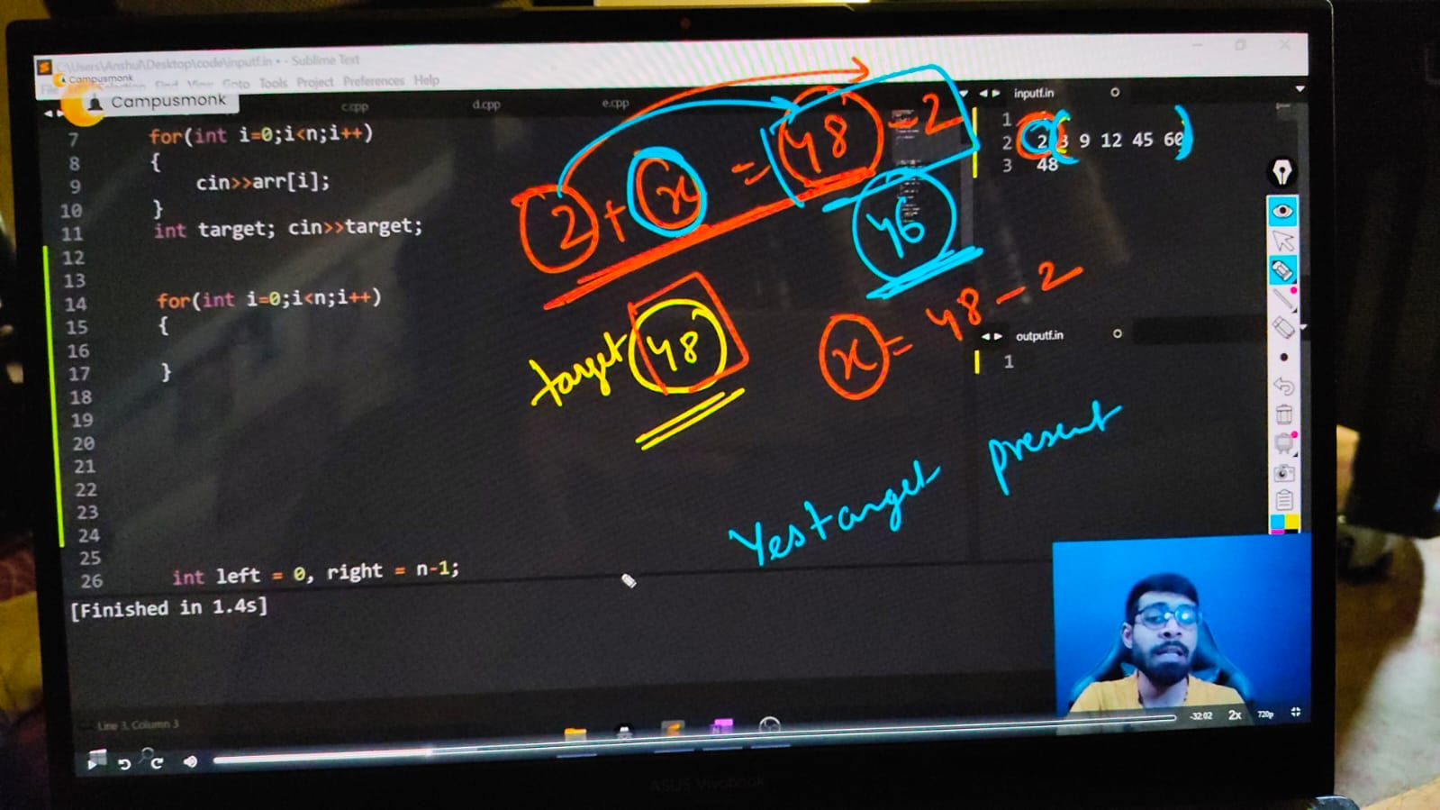

    // 📌- when we solved this concept using 2 for loops then the complexoty was around n^2. so now for decreasingnthis complexity and making iteasy we're tryign with bonary search techniques

    // int n;

    // cout << "Enter the size of array - ";

    // cin >> n;

    // int arr[n];

    // cout << "MEntion the array values you want tot inserett - " << endl;

    // for (int i = 0; i < n; i++)

    // {

    //     cin >> arr[i];

    // }

    // cout << endl;

    // cout << "So, your enteres aray is - " << endl;

    // sort(arr, arr+n);//Sorting the array because what if user coudn;t privde us a sorted arrayu

    // for (int i = 0; i < n; i++)

    // {

    //     cout << arr[i] << " ";

    // }

    // cout << endl;

    // int target;

    // cout << "Now, let me knw what is your Targeted Element" << endl;

    // cin >> target;

    // for (int i = 0; i < n; i++)

    // {

    //     // 📌 Logic - a+b=target. i+find=target. jis elelmtnpr ho use target se substract kr do, vo eleemnt mil jaayga

    //     int a = arr[i];

    //     int find = target - a;

    //     int left = i + 1, right = n - 1;

    //     // i+1 --------n-1

    //     while (left <= right)

    //     {

    //         int mid = (left + right) / 2;

    //         if (arr[mid] == find)

    //         {

    //             cout << "Yes elment's sum equate to target eleemnt" << endl;

    //             cout <<"and the elements are available at "<< i << " " << mid << endl;

    //             return 0;

    //         }

    //         else if(arr[mid]>find)

    //         {

    //             right = mid-1;

    //         }

    //         else

    //         {

    //             left = mid+1;

    //         }

    //     }

    // }

    // cout<<"Not found "<<endl;

/*

Enter the size of array - 5

MEntion the array values you want tot inserett -

10 45 32 98 78

So, your enteres aray is -

10 32 45 78 98

Now, let me knw what is your Targeted Element

42

Yes elment's sum equate to target eleemnt

and the elements are available at 0 1

*/

// T.C - for the given for loop it's O(n) & for Binary Search its O(logn) so total - O(n*logn)

// ____________ ____________ ____________ ____________ ____________

}